**DEPT. OF ELECTRICAL & ELECTRONICS ENGINEERING SRM INSTITUTE OF SCIENCE AND TECHNOLOGY, Kattankulathur – 603203.**

|  |
| --- |
| Title of Experiment : **10. Verification and interpretation of Logic**  **Gates.** |
| Name of the candidate : Debarghya Barik    Register Number : RA2011026010022    Date of Experiment : 05.01.2021 |

|  |  |  |  |
| --- | --- | --- | --- |
| Sl.  No. | Marks Split up | Maximum marks  (50) | Marks obtained |
| 1 | Pre Lab questions | 5 |  |
| 2 | Preparation of observation | 15 |  |
| 3 | Execution of experiment | 15 |  |
| 4 | Calculation / Evaluation of Result | 10 |  |
| 5 | Post Lab questions | 5 |  |
|  | **Total** | **50** |  |

**Staff Signature PRE-LAB QUESTIONS**

1. **Name the different Logic Gates.**

**Ans:** There are **seven** basic logic gates: **AND, OR, XOR, NOT, NAND, NOR, and XNOR.**

1. **List out the IC names for the different logic Gates.**

**Ans:**

* 7408 Quad 2 input AND gates.
* 7432 Quad 2 input OR gates.
* 7404 Hex NOT gates (Inverters)
* 7400 Quad 2 input NAND gates and 74133 Single 13 input NAND gate
* 7402 Quad 2 input NOR gates
* 7486 Quad 2 input XOR gates.
* 747266 Quad 2 input XNOR gates.

1. **What is the Boolean expression for a NOR gate?**

**Ans:** The Boolean expression for a logic NOR gate is denoted by a plus sign, (+) with a line or Overline (‾‾) over the expression

1. **How does a NOR gate work?**

**Ans:** The **NOR gate is** a digital logic **gate** that implements logical **NOR** i.e the result of the negation of the OR operator.

- it behaves according to the truth table

A HIGH output (1) results if both the inputs to the **gate are** LOW (0);

if one or both inputs are HIGH (1), a LOW output (0) results

**5. Expression for Ex-OR and Ex-NOR?**

**Ans:** The Boolean expression of Ex-OR:  Q = (A ⊕ B) = A’.B + A.B’

The Boolean expression of Ex-NOR:  Q = (A ⊕ B)’ = (A.B)’ + A.B

**Experiment No. 10 Verification and interpretation of truth tables for AND,**

**Date : 05.01.2021 OR, NOT, NAND, NOR Exclusive OR (EX-OR), Exclusive NOR (EX-NOR) Gates.**

**Aim**: To verify the Boolean expression using logic gates.

**Apparatus:** Logic trainer kit, logic gates / ICs, wires.

**Theory:** Logic gates are electronic circuits which perform logical functions on one or more inputs to produce one output. There are seven logic gates. When all the input combinations of a logic gate are written in a series and their corresponding outputs written along them, then this input/ output combination is called **Truth Table**. The following logic gates and their working are explained. 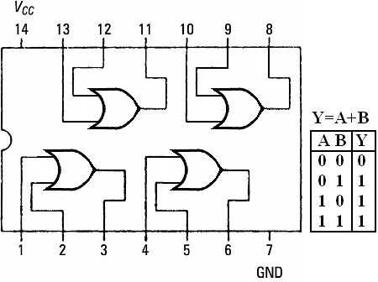

**i) AND Gate**

AND gate produces an output as 1, when all its inputs are 1; other-wise the output is 0. This gate can have minimum 2 inputs but output is always one. Its output is 0 when any input is 0.

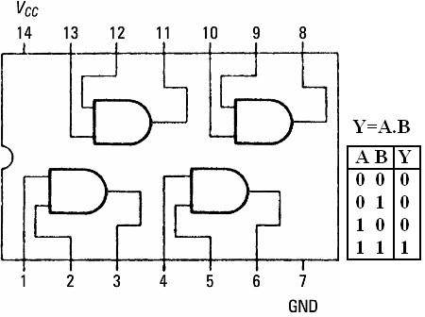

# IC 7408

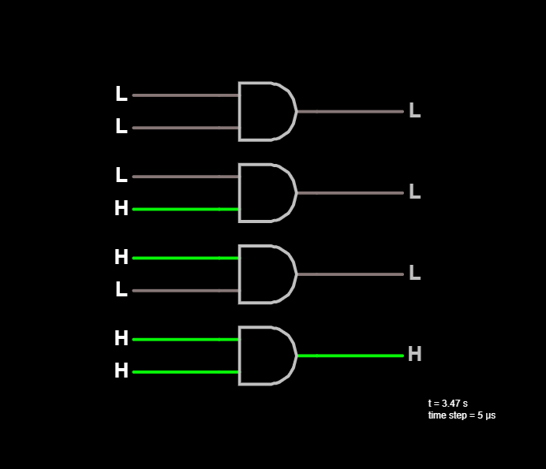

**AND Gate**

1. **OR Gate**

OR gate produces an output as 1, when any or all its inputs are 1; otherwise the output is 0. This gate can have minimum 2 inputs but output is always one. Its output is 0 when all inputs are 0.

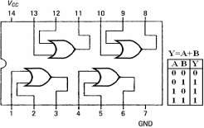

IC 7432

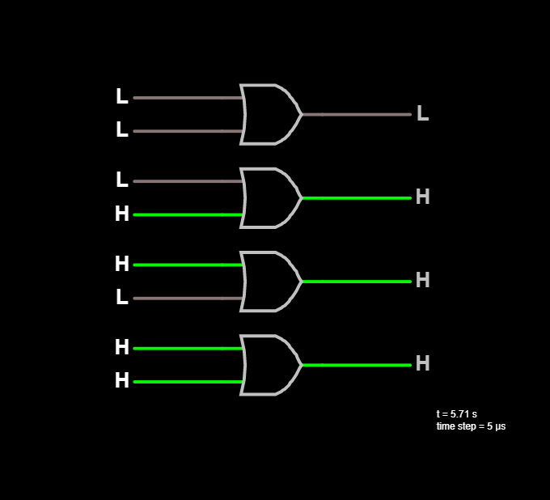

**OR Gate**

1. **NOT Gate**

NOT gate produces the complement of its input. This gate is also called an INVERTER. It always has one input and one output. Its output is 0 when input is 1 and output is 1 when input is 0.

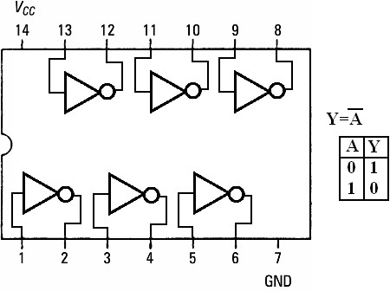

IC 7404

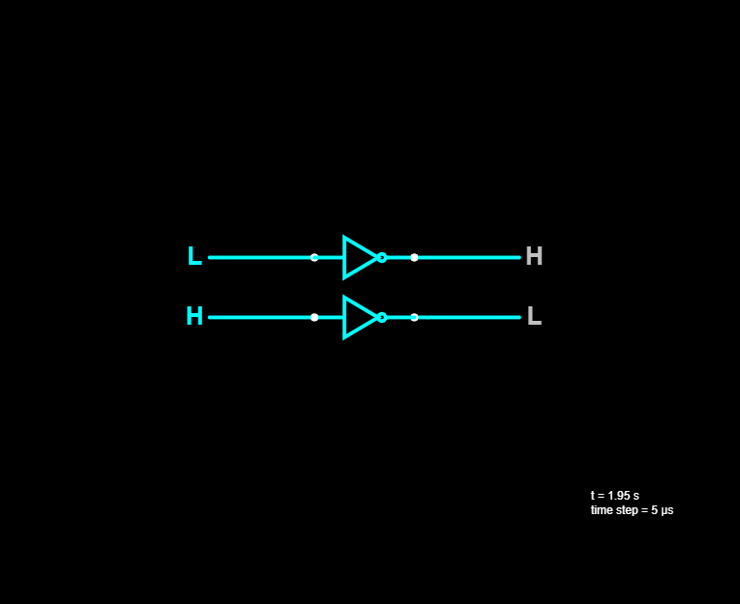

**NOT Gate**

1. **NAND Gate**

NAND gate is actually a series of AND gate with NOT gate. If we connect the output of an AND gate to the input of a NOT gate, this combination will work as NOT-AND or NAND gate. Its output is 1 when any or all inputs are 0, otherwise output is 1.

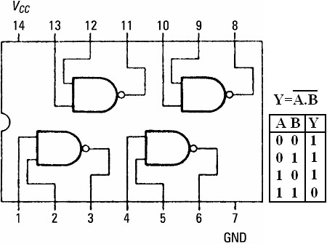

# IC 7400

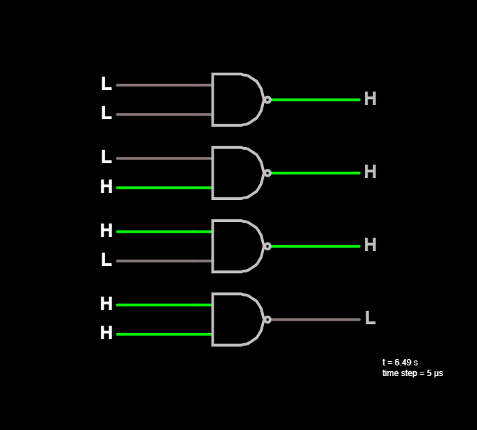

**NAND Gate**

**v) NOR Gate**

NOR gate is actually a series of OR gate with NOT gate. If we connect the output of an OR gate to the input of a NOT gate, this combination will work as NOT-OR or NOR gate. Its output is 0 when any or all inputs are 1, otherwise output is 1.

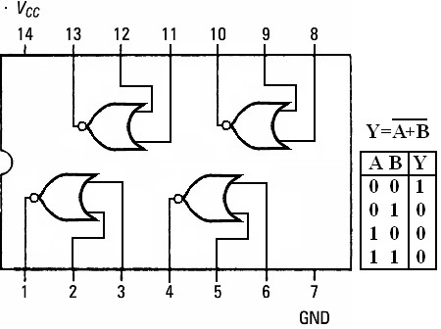

## IC 7402

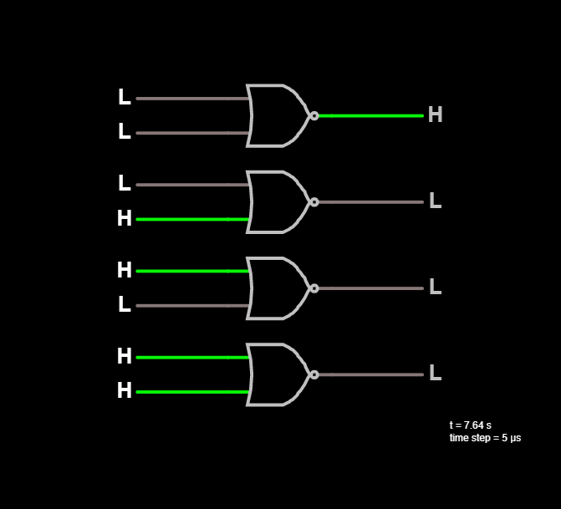

**NOR Gate**

**vi) Exclusive OR (X-OR) Gate**

X-OR gate produces an output as 1, when number of 1’s at its inputs is **odd**, otherwise output is 0. It has two inputs and one output.

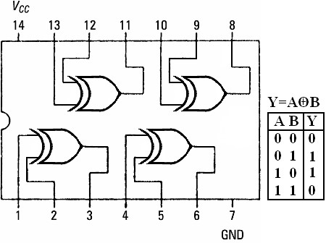

## IC 7486

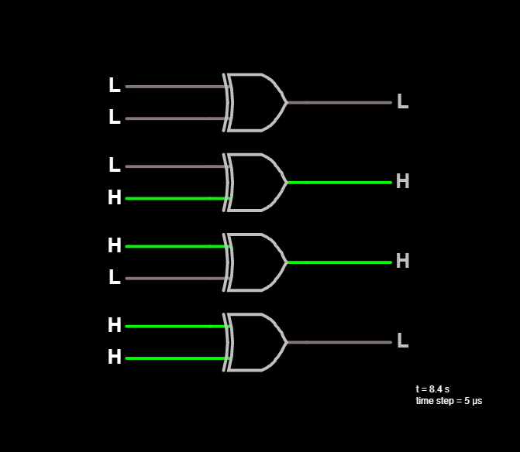

**X-OR Gate**

**vii) Exclusive NOR (X-NOR) Gate**

X-NOR gate produces an output as 1, when number of 1’s at its inputs is **not odd**, otherwise output is 0. It has two inputs and one output.

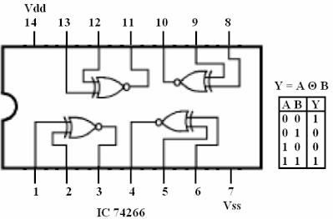

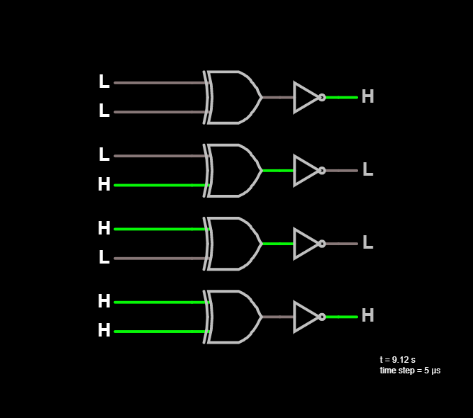

**X-NOR Gate**

**Procedure:**

1. Connect the trainer kit to ac power supply.
2. Connect the inputs of any one logic gate to the logic sources and its output to the logic indicator.
3. Apply various input combinations and observe output for each one.
4. Verify the truth table for each input/ output combination.
5. Repeat the process for all other logic gates.
6. Switch off the ac power supply.

**POST-LAB QUESTIONS**

1. **Name the universal Gates?**

**Ans:** A **universal gate** is a gate which can implement any Boolean function without need to use any other gate type. The **NAND** and **OR**gates are universal gates. In practice, this is advantageous since NAND and NOR gates are **economical** and **easier** to fabricate and are the basic gates used in all IC digital logic families.

1. **Deduce the logic of AND gate using NAND and NOR?**

**Ans:** 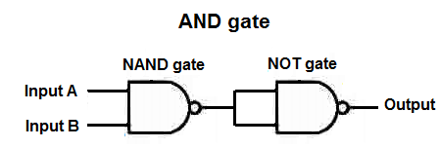

**NAND to AND**

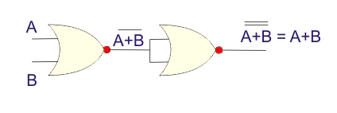

**NOR to OR**

1. **What is the symbol of NAND gate?**

**Ans:**



**Where Q = (A.B)’**

1. **How many NAND gates are required to make an OR gate?**

**Ans: Three NAND** gates are required to make an **OR** gate.

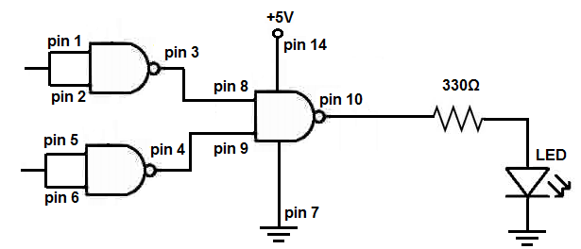

1. **How many NOR gates are required to implement a NAND gate?**

**Ans: Four NOR** gates are required to implement a **NAND** gate.

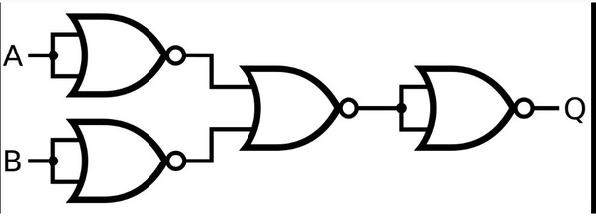

--------------------------------------------------X-------------------------------------------------------